Introduction to ‘EndNote Desktop’ X9 (Mac) – 2019 HANDOUT
If you are using EndNote on an RMIT computer, you don’t need to install the software but please ensure you install the EndNote software if using your own device from: https://www.rmit.edu.au/library/research/endnote-managing-your-references/endnote-desktop.
Also, please ensure that you have Mozilla Firefox https://www.mozilla.org/en-US/firefox/new installed on your MacBook.

This document comprises:

- Introduction and learning outcomes
- Creating and opening a new EndNote Desktop library
- Exporting references from Library databases - EXERCISE ONE
- Exporting references from LibrarySearch - EXERCISE TWO
- Exporting references from Google Scholar - EXERCISE THREE
- Manual input of references - EXERCISE FOUR
- Adding or attaching full-text PDFs
- Groups
- Selecting reference styles
- Using EndNote with Microsoft Word - EXERCISE FIVE
- Backing up your EndNote Desktop library
- Final tips
- Conclusion and further help

1. INTRODUCTION AND LEARNING OUTCOMES
This handout:
- Is at beginner's level and covers only the basics of the EndNote program. It is assumed that you have never used Endnote or are unfamiliar with it.

- Does not teach you how to reference. You are expected to have a basic knowledge of referencing and your School’s referencing style.

- Does not teach you how to search in databases. You are expected to be familiar with basic database searching, as some basic database searching is involved.

- The Library’s subject guide Endnote: a beginner’s guide (http://rmit.libguides.com/endnote) is useful as a self-paced instructional tool.

- Does not cover advanced areas. The following resources address advanced questions:
  - EndNote X9 User Documentation (Win and Mac)
http://clarivate.libguides.com/endnote_training/users/enx9
  - EndNote.com Training
http://endnote.com/training
  - EndNote’s YouTube Channel
https://www.youtube.com/user/EndNoteTraining/videos
  - EndNote.com Community (User Forum)
https://community.endnote.com/t5/EndNote/ct-p/endnote
  - EndNote.com Support – Common Questions
https://support.clarivate.com/Endnote/s/?language=en_US

EndNote Desktop is a software program that:
  - Creates, stores and manages your references/citations.
  - Saves your selected references/citations from online resources (e.g. library databases, Google Scholar, LibrarySearch) to export them into your EndNote Desktop library.
  - Inserts references/citations from your EndNote Desktop library into your Microsoft Word document, and automatically creates a bibliography, so you do not have to manually do so yourself. Bibliographies are created in your chosen referencing style (e.g. APA 6th, RMIT Harvard, RMIT IEEE, Vancouver, Chicago, etc.).

Learning outcomes:
  - Create and open a new EndNote Desktop library.
  - Add references to your EndNote Desktop library -- manually & directly from library databases, LibrarySearch and Google Scholar.
  - Add or attach full-text PDFs to your references.
  - Use EndNote Desktop Microsoft Word in your chosen referencing style.
  - Create groups, change referencing styles and create a backup of your EndNote Desktop library.
  - Know how to get further help for EndNote Desktop.

2. CREATING AND OPENING A NEW ENDNOTE DESKTOP LIBRARY
Additional information on accessing the EndNote program and creating a library can be found at: http://rmit.libguides.com/endnote/getting-started
- Open Finder > Applications > Endnote X9 > Endnote X9.

- Create a new EndNote Library: File > New and save it to desktop, H: drive or USB.

- This will create an .enl file and a .data folder -- both MUST be KEPT TOGETHER in the SAME location for your EndNote Desktop library to work properly. If you move the .enl file to a different location, you MUST move the .data folder with it.

- To open your EndNote Library, click on the .enl file only. The .data folder is only used by the EndNote program.
3. EXPORTING REFERENCES FROM LIBRARY DATABASES - EXERCISE ONE
Exporting from library databases is best for references typically found in databases, such as journal articles and conference papers. Apart from Google Scholar & LibrarySearch, many of the major databases allow this feature: Science Direct, PubMed, ERIC, ProQuest, Academic OneFile, EBSCOhost, Scopus, JSTOR, IEEE, Web of Science and Emerald. Additional information on adding references from a database to an EndNote library can be found at: http://rmit.libguides.com/endnote/add-references-mac
To export references from a library database into your EndNote Desktop Library:
- Ensure your EndNote Library is open.
- Important! Use the Mozilla Firefox as your browser.
- Choose ProQuest OR Science Direct.
- Navigate from library homepage to heading Find Resources, then select Databases > Popular > ProQuest  - Do a search on your topic.  - Tick in the box next to the articles you want to save.  - Click on the icon (on the far right) and select RIS (works with Endnote, Citavi etc.) from the pull-down menu.  - An Export/Save window will appear. Keep RIS (works with Endnote, Citavi etc.) from the top drop-down menu (next to "Output to") selected and click Continue at the bottom of the window.  - At the prompt select ‘Open with’ and Choose: Applications > Endnote X9 (folder) > Endnote X9 (program), and then OPEN. Tick the box for the “Do this automatically for files like this from now on” option. Click OK. Note: There may also be a prompt to select a library. | - Navigate from library homepage to heading Find Resources, then select Databases > Popular > Science Direct.  - Do a search on your topic.  - Tick in the box next to the articles you want to save.  - Press icon.  - Select Export citation to RIS  - At the prompt select ‘Open with’ and Choose: Applications > Endnote X9 (folder) > Endnote X9 (program), and then OPEN. Tick the box for the “Do this automatically for files like this from now on” option. Click OK.  Note: There may also be a prompt to select a library.

Tip: To add the full-text article (PDF) to new record(s), please refer to section 7 or the step-by-step instructions on the EndNote: a Beginner’s Guide under http://rmit.libguides.com/endnote/full-text
NOTES:
- A new imported record(s) will appear in the Imported References folder within your EndNote library. The record(s) will also appear in the All References (master) folder. Each time you export a new record(s), the previous record(s) will be replaced within the Imported References folder, but they are still held in the All References folder.

- Some databases may not export citations directly and may only download a “.ris” file. To export the citation, open the file with EndNote.

- You should always check each exported record to make sure that no information is incorrect or is missing.

- Many databases have the export to EndNote function but they all use different terms. Some examples of the words used by popular databases include: Send to; Export citation(s); Export; Export/Save; Save; EndNote [button].

4. EXPORTING REFERENCES FROM LIBRARY SEARCH - EXERCISE TWO
Additional information on adding references from LibrarySearch to an EndNote library can be found at: http://rmit.libguides.com/endnote/add-references-mac
Exporting from LibrarySearch is best for saving references not usually found in databases such as books, DVDs, videos, etc.

To export references from LibrarySearch into your EndNote Desktop Library:
- Using Mozilla Firefox as your browser, search on a topic in LibrarySearch.
- Select references to export to the Endnote library by selecting the pin to the right of the title in each record.
Note: To export a single LibrarySearch record, select the Export Record (RIS) option to the right of the title in the record. Then go to step 5.
- Select ‘Favourite‘ at the top right of the screen

- Select the records and, from the options next to the My Favourites heading, select ”Push to” action
- Select Export Record (RIS) 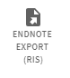
- From the drop down Encoding menu, select the UTF-8 option. 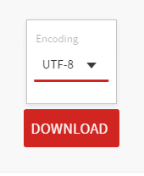 Press the Download button.
- To export records, select ‘Open with’ and Choose: Applications > Endnote X9 (folder) > Endnote X9 (program), and then OPEN. Tick the box for the “Do this automatically for files like this from now on” option. Click OK. Note: There may also be a prompt to select a library.

- Your LibrarySearch references have now been exported into your EndNote Desktop library.

NOTE: You should always check each exported record to make sure that no information is incorrect or is missing.
5. EXPORTING REFERENCES FROM GOOGLE SCHOLAR - EXERCISE THREE
Additional information on adding references from Google Scholar to an EndNote library can be found at: http://rmit.libguides.com/endnote/add-references-mac
Google Scholar is best for searching academic material on the internet. References from Google Scholar searches can be exported into an EndNote library.
To export references from Google Scholar into your EndNote Desktop Library:
- Ensure your EndNote Desktop library is open.

- Using Mozilla Firefox as your browser, navigate to Google Scholar from the Library homepage (Find Resources > Other Sources > Search Google Scholar). If prompted, log in with your RMIT student / staff number and password. Logging on in this step will authenticate you as an RMIT student / staff member, so you can access the full-text of our online resources.
- Click on the Sign in button (top right of screen) and log in with your RMIT email address and Password. You're now signed in to your Google Scholar account -- you can Sign Out (top right of screen).

Note: If you have entered your RMIT e-mail address, clicked on Next and nothing happens, or if you receive the following message at this step -- 'Something went wrong, Sorry, something went wrong there' -- go directly to Google Scholar (https://scholar.google.com.au/) and log in via the above Sign in button again using the same e-mail address.
- Search on a topic in Google Scholar https://scholar.google.com.au/
- Click on the white star for each reference you want to export into your EndNote library. This will save the reference to My Library.

- When a reference has been saved to My Library, the white star changes colour to blue . Clicking on the blue star removes the reference from My Library.

- Click on My Library on top right corner.
In here, you'll see a list of all the references you've saved in Step 5. Tick the references you want to export into your EndNote library.

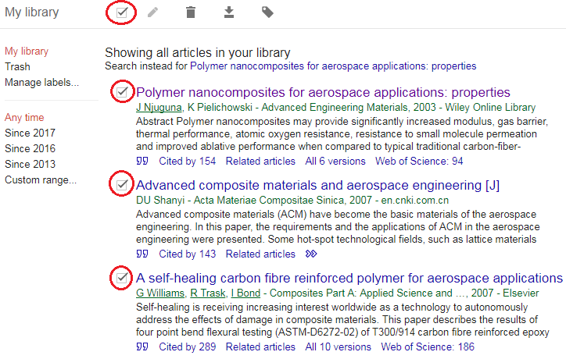
- Press the Export button and select EndNote. If you are using Firefox, it will give you the option to either save or open the file.

Your EndNote library must be open for this step.

- Your Google Scholar references have now been exported into your EndNote library.

NOTE: Always check each exported record to make sure that no information is incorrect or missing.

Tip: When you open the .enw file, if you are asked what program to open it with, select EndNote (you may need to browse the list of programs) and tick the option to always use this program to open these files.

6. MANUAL INPUT OF RECORDS - EXERCISE FOUR

References can be manually entered into an EndNote Desktop library. Manual entry is needed when the resource you are using is not in LibrarySearch, library databases or Google Scholar, and thus does not have the option to be exported into EndNote Desktop. An example of a reference requiring manual entry would be a report from a government department’s website, or information your find on other websites.

To manually enter references into your EndNote Desktop Library:
- Create a new reference by selecting References > New Reference

The default setting for new references is Journal Article. Change the reference type using the Reference Type drop-down menu (top left corner). Demonstrate the different templates for references – e.g., journal article, book, web page.

- Fill in the content for the fields you need. To practice doing this, you can manually enter the sample references from the next page. After entering the details, click on the small red dot at top left to close

(If a pop-up asks to save changes to the record, tick the box saying, ‘Do not show this message again’, and click ‘Save’. The next time it will automatically save).
- You can view or add full-text PDFs. See section 7 - ‘Adding or attaching full-text PDF’s’ for more detail.

- Change the layout by clicking on (top right corner of screen)
- Depending on your choice of layout, you can make quick corrections in a citation’s fields, preview your referencing style, or view the pdf.

NOTES:
- For manual entry of a reference - the Minimum Fields handout specifies the fields that need to be completed for different types of references.

Tips:
- List author last name (family/surname) first and follow with a comma – e.g., Benton, Tim
- Organisation names should be entered in full and follow with a comma – e.g., “RMIT University,”
- Enter each author name on a separate line.
- Space between author initials.
- Full stop after each author initial – e.g., Smith, J. O.
- Sentence case for journal article titles.
- Enter some keywords for searching later.

List of references to practice manual entry (in RMIT Harvard style):

Book
Gartner, LP & Hiatt, JL 2015, Cell biology and histology, 7th edn, Wolters Kluwer Health, Philadelphia.
Journal article
Vladut-Severian, I 2013, 'Urban sustainability and integrated urban water management', Journal of Engineering Studies and Research, vol. 19, no. 4, pp. 25-33.
Web Page
Murray-Darling Basin Authority n.d., Salinity, Murray-Darling Basin Authority, viewed 5 December 2018, <https://www.mdba.gov.au/managing-water/salinity>.
Article from a newspaper website
Presiss, B 2012, ‘Academic calls for plagiarism rules overhaul’, Sydney Morning Herald, 20 August, viewed 19 January 2015, <http://www.smh.com.au/national/academic-calls-for-plagiarism-rules-overhaul-20120820-24imt.html>.
Blog
Eaton, S 2013, ‘What is the difference between a citation and a reference’, Literacy, Languages & Leadership, blog post, 18 October, viewed 19 January 2015, <https://drsaraheaton.wordpress.com/2013/10/18/whats-the-difference-between-a-citation-and-a-reference/>.
Government report
Department of Education and Training 2014, Boosting the commercial returns from research, Australian Government, viewed 20 January 2015, <https://submissions.education.gov.au/Forms/higher-education-research/Documents/Boosting%20Commercial%20Returns%20from%20Research%20%20-%2024102014.pdf>.

7. ADDING OR ATTACHING FULL-TEXT PDFs

Once you have populated your EndNote Desktop library by inserting references from library databases, LibrarySearch, Google Scholar or manual input, you can attach their full-text PDFs (the whole article or paper) to new references. You can do this only for online journal articles and conference papers, not e-books. Please refer to the step-by-step instructions: http://rmit.libguides.com/endnote/full-text.

Alternatively, if you already have a folder of PDFs on your computer, you can import them into your Endnote Desktop library to have EndNote automatically create their references. Please see the Adding full-text PDF articles to create new references (PDF Import option) box within the above link.

8. GROUPS

Groups make it easy to break a large library into subsets for later viewing. A group simply points to a subset of references that already exist in the library.
To create Groups:
- Create a Custom Group:

- Right-click on My Groups, or from the menu Groups > Create Group and name it after a topic. Demonstrate dragging and dropping some references into a Group. Custom groups work on the “drag and drop” method.

- Create a new Smart Group:

  - Right-click on My Groups, or from the menu Groups > Create Smart Group and name it after a topic. In Any Field, set up a search for a word that commonly appears in your references (have a look at the title or abstract) – this creates a group that will automatically add references if they have your chosen word in the citation.

9. SELECTING REFERENCING STYLES
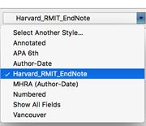
In order for EndNote to correctly display your references in both your EndNote Desktop library and your Microsoft Word document, you will need to choose the referencing style you would like to use within your library and document. The style selected should be the same in both.

To select your referencing style in EndNote Desktop:

- Click on the Style drop-down list and select your style.

- Click Choose to add it to the list for quick access.

- If your style is not within the list, click Select Another Style. Then select the style you want from the Choose A Style pop-up box, e.g. Harvard_RMIT_EndNote, IEEE_RMIT_EndNote.

- Other styles not in the EndNote list can be downloaded via EndNote: Edit > Output styles > Open Style Manager > Get More on the Web.

- RMIT staff and students using RMIT Harvard referencing style and using EndNote on a personal computer, will need to download the RMIT Harvard Style (Harvard_RMIT_EndNote) available from the library’s EndNote website within the Downloads tab - https://www.rmit.edu.au/library/research/endnote-managing-your-references

10. USING ENDNOTE DESKTOP WITH MICROSOFT WORD - EXERCISE FIVE

In order for Microsoft Word, EndNote Desktop and the Windows operating system to work properly with each other, specific compatibility and system requirements need to be met.

Open your own Word document to practice or, alternatively, you can download the Library’s sample Word document:

Instructions if using sample Word document:
- From the library’s EndNote help and training website (https://www.rmit.edu.au/library/research/endnote-managing-your-references/endnote-help-and-training), select the Practice documents tab.

- Right-click on sample Word document 'Information literacy' practice document (DOC, 20 KB), and save onto desktop (no need to rename).

- Open your Word document. EndNote X9 appears as a separate tab in Word.

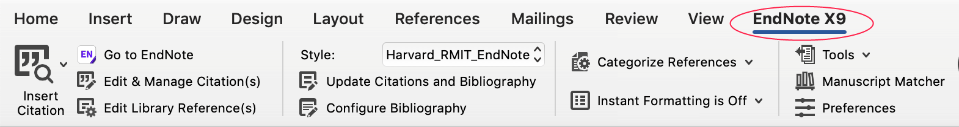

Tip: When you open your Word documents, you should ensure that the selected referencing style (RMIT Harvard, APA, Vancouver, etc.) is the same as the selected referencing style in your EndNote Library. If not, references will incorrectly display in your Word document.

- Inserting references in Word - Two methods

Method A
- In Word, select where you would like to insert the citation in the text.
- In EndNote, highlight the reference and select Insert Citation.
- The reference(s) will be inserted into the text of the Word document, and a Reference List or Bibliography will be created the end of the document.

Method B
- In Word, select where you would like to insert the citation in the text.
- Select Search EndNote library from the EndNote tab 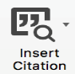
- Search for a reference (e.g. use the author's surname), hit 'return'.
- Once the correct reference appears click Insert.
- The reference(s) will be inserted into the text of the Word document, and a Reference List or Bibliography will be created the end of the document.

3) Editing in-text citations in Word

For Page numbers:

- In Word, place cursor on in-text citation.
- From the EndNote tab, select Edit & manage citation(s):
  - Enter page number for an in-text citation. Enter page numbers in the ‘Pages’ field > press OK.
Tip: Page numbers will only appear if the Style allows it (e.g. APA, Harvard RMIT).
Excluding author or year from an in-text citation:

- Click the Formatting drop-down menu within the Edit Citation tab > select Exclude Author or Exclude Year > press OK.

4) Remove an in-text citation in Word:

- In Word, place the cursor on the citation you want to delete.
- From the EndNote toolbar, select Edit & manage citation(s).
- Click the drop-down arrow to the right of the citation you want to remove and select Remove Citation. Click OK.
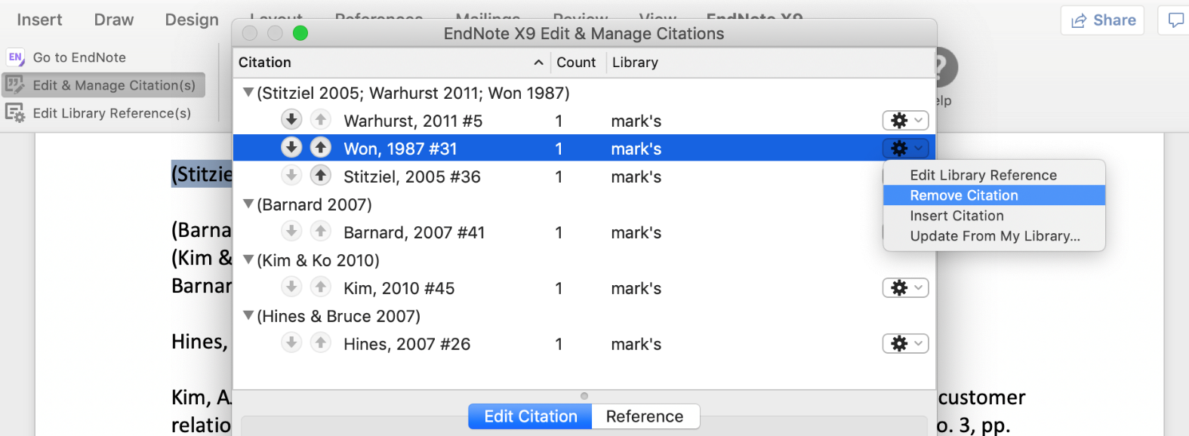

Tips: Do NOT remove or delete a reference in Word using the DELETE key.
Removing an in-text citation from Word does NOT remove the reference from your EndNote Library – it only removes that single instance from your Word document.

NOTE: If any reference in the EndNote Library is edited, changes made will NOT be reflected in the Word document until you update the Bibliography. To do so, use the Bibliography drop-down arrow in the EndNote toolbar.

11. BACKING UP YOUR ENDNOTE DESKTOP LIBRARY

It is important to regularly save and backup your EndNote Desktop Library to ensure you do not lose your work. You do this by creating a compressed EndNote Desktop Library. Please refer to the step-by-step instructions: http://rmit.libguides.com/endnote/backup.

12. FINAL TIPS
- EndNote basic
http://rmit.libguides.com/EndNote_Online

Library homepage > All subject guides > Reference > Go > Endnote: a Beginner's Guide> EndNote Online (EndNote basic)

EndNote basic is the condensed online version of the EndNote Desktop program. EndNote basic allows you to sync your EndNote Desktop Library with EndNote basic so you can use your Library, ‘in the cloud’, anywhere with internet access. You can also use EndNote basic on its own as an alternative to using EndNote Desktop. To use EndNote basic, you will first need to create an EndNote basic account: https://www.myendnoteweb.com/

For more information, refer to: http://endnote.com/product-details/basic
https://www.rmit.edu.au/library/research/endnote-managing-your-references/endnote-basic

- EndNote: a Beginner’s Guide
http://rmit.libguides.com/endnote

Library homepage > All subject guides > Reference > Go > Endnote: a Beginner's Guide

You can use this guide as a self-paced instructional tool - anytime, anywhere – to: 1) go through what was outlined in this document to reinforce your understanding, 2) follow up on what you didn't fully understand in this document, 3) or explore other EndNote features not covered in this document (e.g. adding full text, Journal Term Lists, EndNote basic, etc.)

- EndNote: Managing your References
https://www.rmit.edu.au/library/research/endnote-managing-yeour-references/endnote-help-and-training

Library homepage >Services and help > EndNote: manage your references> Help and training

This is the official EndNote website from RMIT Library. You can access online tutorials, webinars, discussion forums and the EndNote Beginner's Guide from the Help & Training section. You can also download the EndNote program, Styles and other files to your own computer from the Downloads section.

13. CONCLUSION AND FURTHER HELP

- RMIT Library cannot fix complex technical problems with specific Endnote libraries and documents. If you require advanced technical troubleshooting, please refer to Endnote.com

- If you have technical issues with downloading or installing EndNote, please contact the RMIT IT Service - https://www.rmit.edu.au/students/support-and-facilities/it-services-for-students/service-and-support-centre

- Students and staff can ask for EndNote assistance in person at any RMIT Library service desk or via Ask the Library - https://www.rmit.edu.au/library/help/ask-the-library

- The Help and Training section on the EndNote: a Beginner’s Guide lists various resources you can consult for further assistance - http://rmit.libguides.com/endnote/help

- As EndNote is not a substitute for knowing how to reference, you should become familiar with the referencing style your School, supervisor or lecturer wants you to use. Learn how to reference using the resources below:

- Easy Cite referencing tool
- Referencing guides for printing
- Learning Lab: Referencing

