Using the RMIT_Harvard_EndNote reference style on a personal device
To ensure consistency between the RMIT Harvard EndNote reference style and the Library’s Easy Cite referencing tool, it is recommended that the RMIT Harvard preference file is downloaded and imported into your EndNote Library on your personal device.

Instructions for using the EndNote Preference File

To use the RMIT_Harvard_EndNote reference style, you will need to do the following:
- Download the RMIT_Harvard_EndNote reference style file and save it in the Styles folder within the EndNote program.
- Download the RMIT Harvard Preference File.
- Download the RMIT Harvard Minimum Fields document.
- Download the original EndNote Preference File.
  - This original file will be required if you use multiple referencing styles. For example, RMIT Harvard and also IEEE.

Note: Import the RMIT Harvard Preference File, when using the RMIT_Harvard_EndNote reference style.

Complete the following steps to import the RMIT Harvard Preference File into an EndNote Library:

- On a PC / Windows device,
from the EndNote program,
select the Edit Menu and
choose Preferences…

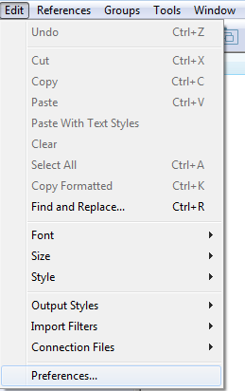
- On a MAC / OS device,
from the EndNote program,
select the EndNote Menu and
choose Preferences… ⌘,

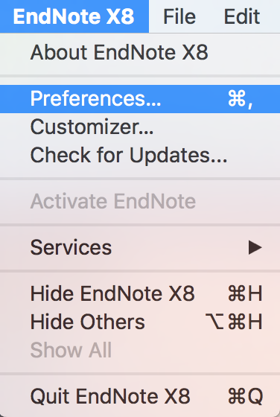

- In the EndNote Preferences window, select Reference Types from the left-hand menu.

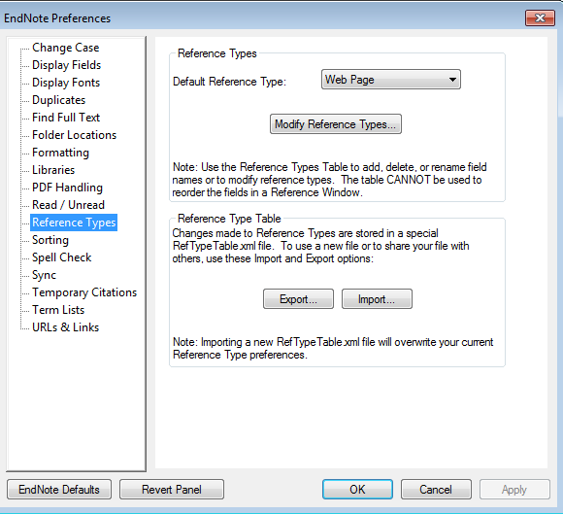

- Press the Import button from the Reference Type Table section
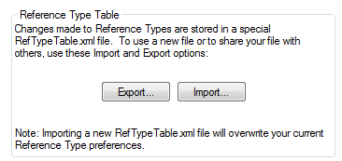

- From the Downloads folder on your computer, find the RMIT Harvard Preference File and open the file.
- Select Apply from the EndNote Preferences window.
- Select OK.

Changing from the RMIT_Harvard_EndNote reference style to another reference style (for example IEEE) on a personal device

Use the original EndNote Preference File if you are changing from RMIT Harvard to another referencing style in your EndNote Library.

To import the EndNote Preference File, follow the steps below:

- From the EndNote program, select the Edit Menu and choose Preferences…
- In the EndNote Preferences window, select Reference Types from the left-hand menu.
- Press the Import button from the Reference Type Table section
- From the Downloads folder on your computer, find the EndNote Preference File and open the file.
- Select Apply from the EndNote Preferences window.
- Select OK.

